Name _______________________________________ Period _______ Date: _____________

Genetics Pre-Assessment

The rock pocket mouse is type of mouse that lives in the southwestern U.S. and Mexico. Most of these mice are tan; however some of these mice have black fur. The only difference between a tan mouse and black mouse is a single gene that relates to fur color.

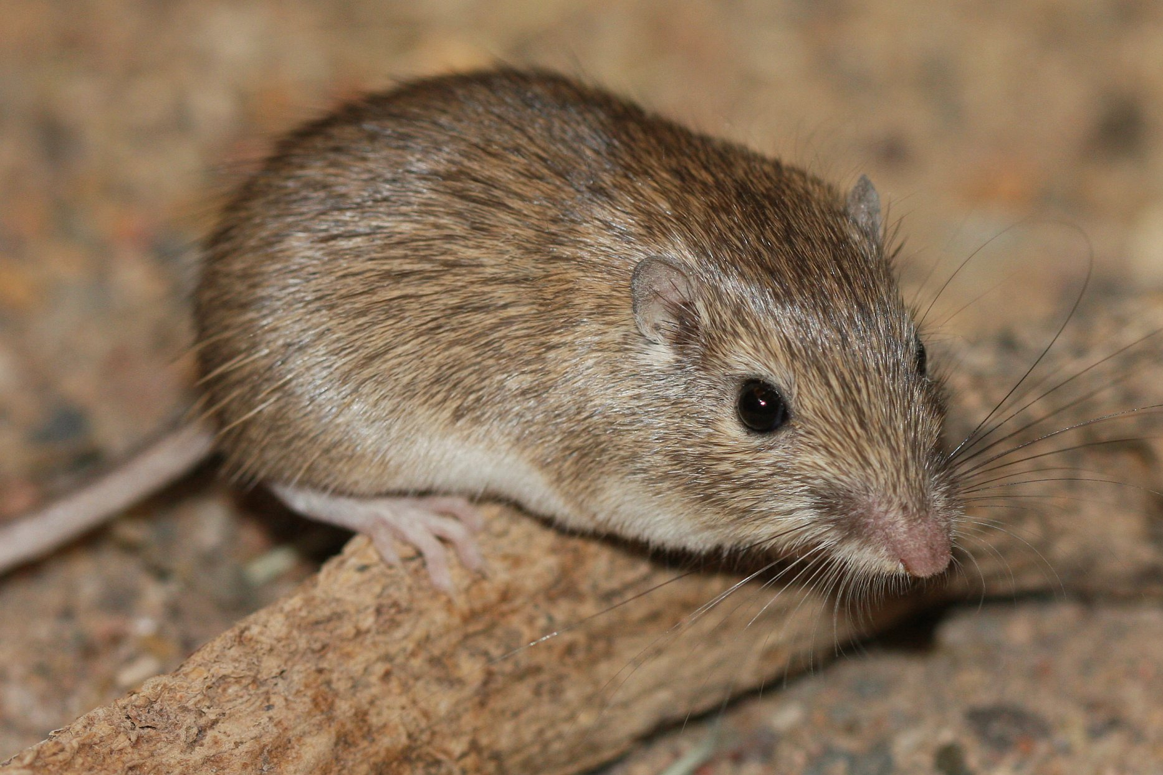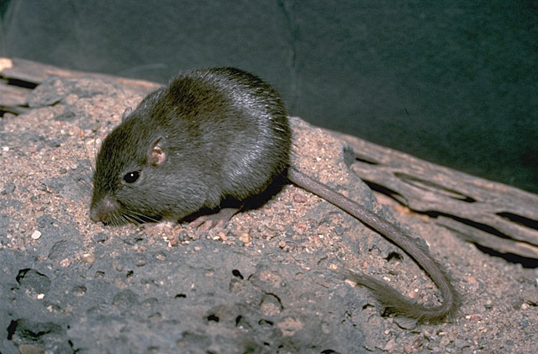

A. Explain how a difference in a gene between a tan mouse and a black mouse could result in the different fur colors.

B. Draw and label diagrams to support your explanation for the differences between tan and black mice. Note: You must write a thorough explanation; a diagram by itself is not sufficient.
You may also use the back of this sheet.

