Proteins Reading Honors Name
Read the following two pages and answer the analysis questions on the next page. Highlight or underline new vocabulary terms as you go along with any other important concepts/ideas.

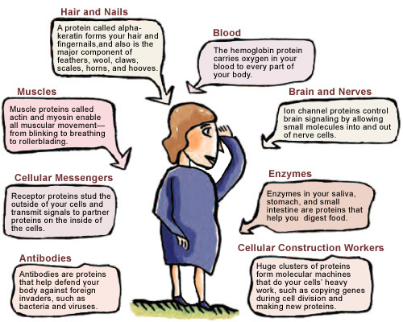
Proteins are in First Place!
The word protein comes from the Greek word meaning “first place,” highlighting the importance of proteins in biology. All living organisms contain hundreds to tens of thousands of different kinds of proteins. Each different kind of protein has a unique, three-dimensional structure that corresponds to a specific function. This diversity in protein structure and function allows proteins to provide the molecular tool kit for almost everything cells do. Proteins are responsible for almost all of the day-to-day functioning of organisms:
- Proteins form body and cell structures, including hair and muscles
- Proteins transport materials across the body and in and out of cells, also allowing cells to communicate with each other.
- They play a significant role in the immune system and control most of the chemical reactions in cells.
Although proteins perform all of these very different types of functions, the basis for each of these functions is the structure of the individaul protein that performs that action.
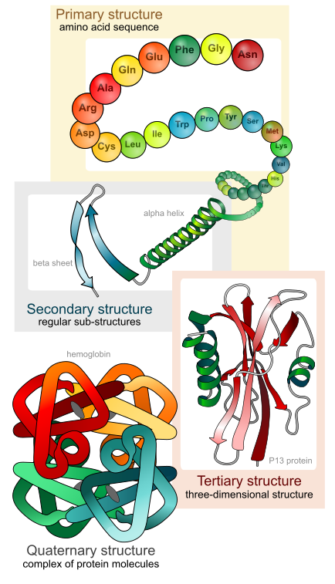
Structure = Function. Period.
A protein is a polymer built from amino acids. There are only about 20 different amino acids in cells that arrange in various combinations to form thousands of unique proteins. Think of how you can form thousands of different English words by using different combinations of the 26 letters in the alphabet. Though the protein alphabet is slightly smaller, 20 amino acids “letters”, the “words” are much longer. Most proteins are at least 100 amino acids in length, with many reaching into the 1,000s and some into the 10,000s. Just as each word in the English language is constructed from a unique sequence of letters, each protein has a unique sequence of amino acids.

While the structure of a protein is based on the sequence of amino acids it is made of, the amino acids don’t remain in a simple straight line like beads on a string. The chain folds into a particular shape based on the sequence of amino acids. Accordingly, a functional protein consists of an amino acid chain precisely twisted, folded, and coiled into a unique shape. The overall shape of the protein molecule determines its function. For proteins to function properly, they must retain their three-dimensional shape. When the structure of a protein (its shape) is lost, it usually loses its function. For example, we witness proteins losing their shape when we fry an egg and watch it go from clear to white as it “cooks”. The white of the egg is formed mostly of a single type of protein. When this protein is exposed to high temperatures (frying), the bonds between some of the folds of the protein break, and the protein loses its shape. This disruption of protein folding is called denaturation and makes the protein nonfunctional.
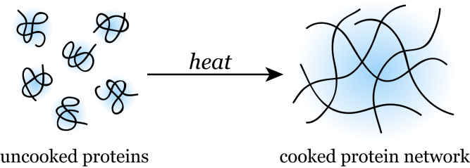
Take-Home Message
The particular amino acid sequence of a protein determines how it folds into a particular three-dimensional shape. This shape determines the function of the protein. When a protein’s shape is changed, the protein usually loses its ability to function.

Enzymes – Make Stuff Happen
Enzymes are a class of proteins that speed up chemical reactions. These molecules are known as catalysts and they act to catalyze reactions. Every cell is capabale of performing thousands of different chemical reactions, and enzyme catalysts are responsible for controlling the rate at which these reactions happen. Enzymes are specific for each reaction and emerge unchanged from a reaction. This allows enzymes to be used again and again. Because of their ability to catalyze reactions, enzymes are at the heart of the chemistry of all living organisms. Metabolism is the name for all of the chemical reactions in a living organism. (It should also be noted that most protein enzymes have names that ended in the suffix –ase.)
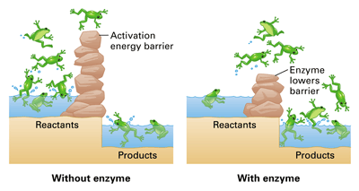
To start a chemical reaction, the chemical bonds in the reactant molecules must be weakened and this requires an initial start-up, or activation energy. Enzymes lower the activation energy needed to get a reaction started and therefore allow the reaction to occur more quickly than without the enzyme.

Protein structure is particularly critical for enzyme function because the shape of the enzyme allows it to catalyze a single chemical reaction and bind with only the reactant molecules for that particular reaction. A specific reactant acted upon by an enzyme is called the enzyme’s substrate. The substrate fits into a particular region of the enzyme known as the active site. This is often visualized like a lock and key, in which the enzyme is the lock, the keyhole is the active site, and the key is the reactant substrate. The fit between the active site and the substrate is somewhat flexible. As the substrate enters, the active site changes shape slightly in response to the substrate, binding the substrate more tightly and weakening the bonds of the substrate(s) itself. This allows the substrate bonds to either break more easily than without an enzyme catalyst, or positions two substrates in such a way that they bond together more easily than if they were simply floating in cellular space. Remember, that it is the shape of the enzyme that allows it to have the function of catalyzing these reactions.

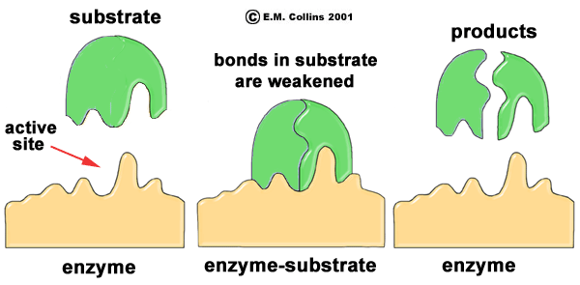
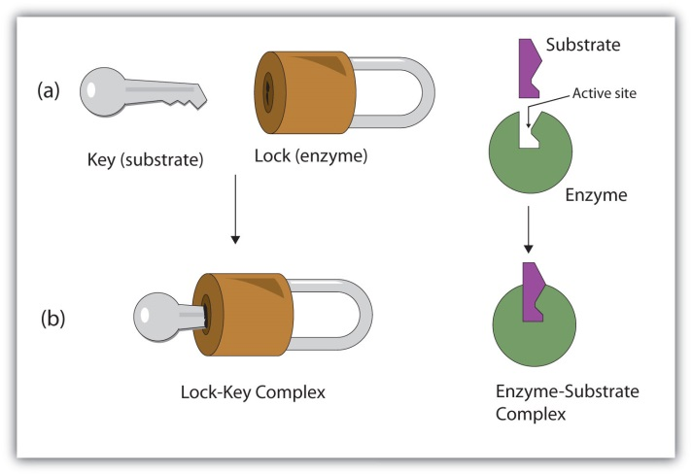

The rate at which an enzyme catalyzes a reaction is influenced by several chemical and physical factors. The shape of the enzyme determines the fit between the enzyme and substrate. If enzyme structure is lost or changed, the enzyme may no longer function to catalyze a reaction because the substrate will no longer be able to bind the active site. For example, increases or decreases in temperature can denature (change the shape) of a protein, and therefore affect the rate at which an enzyme catalyzes its specific reaction. Enzyme, substrate, and product concentration can also affect the reaction rate.

Analysis Questions

- Why is shape so important for proteins?

- Why do the shapes of proteins or enzymes differ from other proteins or enzymes?

- What would happen if the shape of the enzyme or protein were to change when it wasn’t supposed to?

- Why is the enzyme’s active binding site somewhat flexible?

- Using your results (data) from the Lactase Lab and information from this reading, describe what happened to cause a non-functioning lactase enzyme.

- What is something you learned in this reading that was new to you?

- List at least two questions you have after this reading.

