Physical Science: Properties of Matter Name: ________________________________ Per: __________

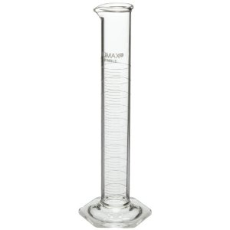
Density of Unknown Liquids Lab

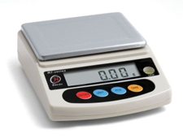
Objectives:
- Determine the density of unknown liquids
- Identify diet and regular beverages based on density.

Materials: Digital Scale, Graduated Cylinder, Small Cup, Unknown Liquids

Procedure:
- Measure 10 mL of an unknown liquid using the graduated cylinder.
- Record the exact volume and sample number in the data tables below.
- Place the small cup on your digital scale and zero (“tare”) the scale.
- Pour the measured liquid into the small cup and record its mass in the data table below.
- Clean and dry the graduated cylinder and cup.
- Repeat steps 1-5 for each of the liquid samples.
- Use the formula density: $D=\frac{m}{V}$ to calculate the density of each unknown liquid.
- Use the Density Table on the back of this sheet to predict which liquid your sample is.
Data

Liquid Sample Number | Liquid Volume: V (mL) | Liquid Mass (g) | Density$: D=\frac{m}{V}$ (g/mL) | Prediction: Which liquid is it? (Use Density Table on back)

Density Table
Density (g/mL) | Liquid
0.761 | Rubbing Alcohol
0.985 | Diet Coke
0.991 | Tap water
0.992 | Vitamin Water Zero
1.015 | Vitamin Water
1.017 | Coke Classic
1.140 | Salt Water

Analysis:

- Which sample do you think was Coke Classic and which was Diet Coke? Why?

- Compare the densities of Diet Coke, tap water, and Coke Classic. Use these numbers to explain why Diet Coke floats and regular Coke sinks in tap water. (Be sure to refer to the actual numbers in your explanation.)

- In this lab, we measured 10mL of each mystery liquid. Would the densities of the liquids change if we had measured 20mL of each liquid? Why or why not?

- In the density table above, salt water is more dense than Coke Classic. Draw a particle diagram for these two liquids, clearly showing their difference in density. Label the particles in your diagram.

Salt Water Coke Classic

- Challenge: How much volume of the least dense liquid would you need to measure to equal the mass exactly 10 mL of the densest liquid? Show your work.

