Name: _____________________________________________ Per. _____ Date: _____________________

Chemistry: Chapter 1 Reading

- Define the following terms:

Matter:

Atom:

Molecule:

- What two big ideas make up the Kinetic-molecular theory of matter?

A.

B.

- Compare and contrast how particles move in solids, liquids, and gases.

Solids Liquids Gases

- Draw circles and motion lines in each box to show differences in the movement and arrangement of water molecules in cold, room temperature, and hot water.
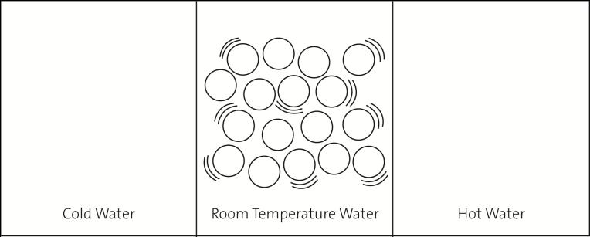

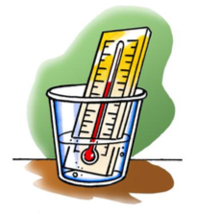
- Thermometers have a very thin tube inside of them that stretches up from a round bulb, which holds most of the liquid.

- Why does the red liquid move up the tube when a thermometer is heated?

- Why does the red liquid move down the tube when a thermometer is cooled?

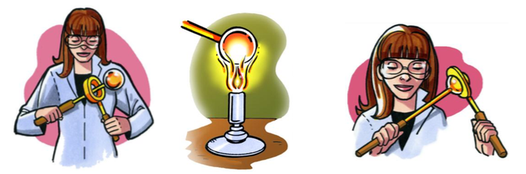
- There is a metal ball and ring set that is specially made so that at room temperature the ball fits through the ring. However, when the ball is heated, it gets stuck and cannot fit through anymore. When heated, the ball actually gets a little bigger! Explain how the motion and attractions of the atoms in the metal ball cause it to get slightly larger when heated.

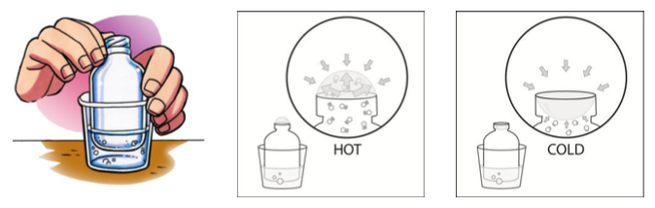
The bottle in each picture is “empty” and has a thin film of bubble solution stretched over the top. When placed in a cup with hot water, a rounded bubble forms at the top. When placed in cold water, the bubble shrinks and turns inside out in the bottle. Answer the questions below by describing what each illustration is trying to show.

- Why does a bubble form on the top of the bottle placed in hot water?

- Why does the bubble shrink when the bottle is placed in cold water?

